38

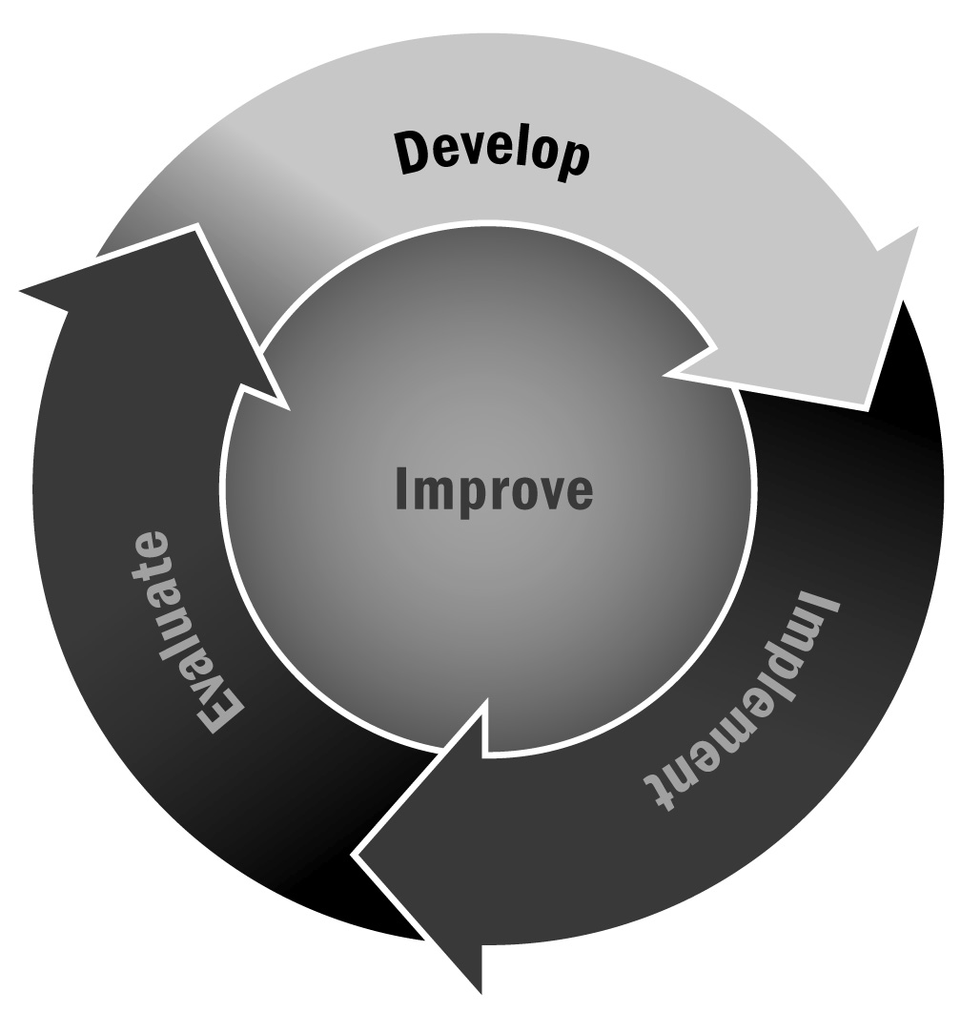
Developing SMART Outcomes
In Chapter 2, you learned that you need to develop a set of intended outcomes for your program that accompany your vision and goals. These outcomes should be SMART (Specific, Measurable, Achievable, Relevant, Time-Specific) in order to be useful. This tool will help you begin to identify outcomes and to determine whether they meet the SMART criteria.
Directions: Use the definitions below to help you fill out the table on the next page. Start by working with your team to develop a set of draft outcomes. Try to think of a realistic number (maybe four to six), and write them down in the left-hand column of the table. Then, once you have identified the outcomes, fill out the SMART table for each outcome to determine whether it meets the criteria. If one does not meet the criteria, work to revise it until it does.
Specific – It is easy to create broad outcome statements that don’t clearly mean anything. Instead, outcomes should be clear, and they should identify specifically what it is you will achieve with your program.
Measurable – Outcomes are not useful to you if you can’t measure them. Make sure it is possible to measure the outcome so there is some concrete or tangible way to identify whether the outcome has been achieved.
Achievable – Nothing is more frustrating for staff, funders, and program leaders than creating lofty outcome goals that are impossible to accomplish. Your outcomes should be things you think your program can accomplish either in the short or long term. They need not be easy and basic—you should stretch yourself a bit—but they do not need to be so big that they are unattainable.
Relevant – Outcomes should be relevant to your program. Don’t plan to have an impact on things that your program doesn’t target. Choose outcomes that are specifically related to the program activities you are planning.
Time-Specific – Outcomes should be tied to a specific time frame, rather than being left open, in order to encourage staff members and partners to work toward them.

Developing SMART Outcomes

Outcome | Is It Specific? | How Will You Measure It? | Is It Achievable? | Is It Relevant? | When Will It Be Achieved?
Example:  Youth will have an increased knowledge of STEM-related careers. | Yes  No | We will host a STEM fair where pairs of young people will present a STEM career that they researched. After the fair, we will ask young people to reflect on what they learned from the project and the fair in their portfolio. We will document their learning from their portfolio reflection. | Yes  No | Yes  No | At the end of the session
 | Yes  No |  | Yes  No | Yes  No
 | Yes  No |  | Yes  No | Yes  No
 | Yes  No |  | Yes  No | Yes  No
 | Yes  No |  | Yes  No | Yes  No
 | Yes  No |  | Yes  No | Yes  No

